Arduino Lesson 22
Stepper Motor
Stepper motor is a kind of actuator to turn electrical pulses into angular displacement. In other words, when the stepper driver receives a pulse signal, it drives the stepper motor to make a fixed angle and the step angle as given direction. You can control the amount of angular displacement by controlling the pulse number for accurate positioning. In the mean time you can control motor rotation speed and acceleration by controlling the pulse frequency as well for speed control.
Hardware Overview
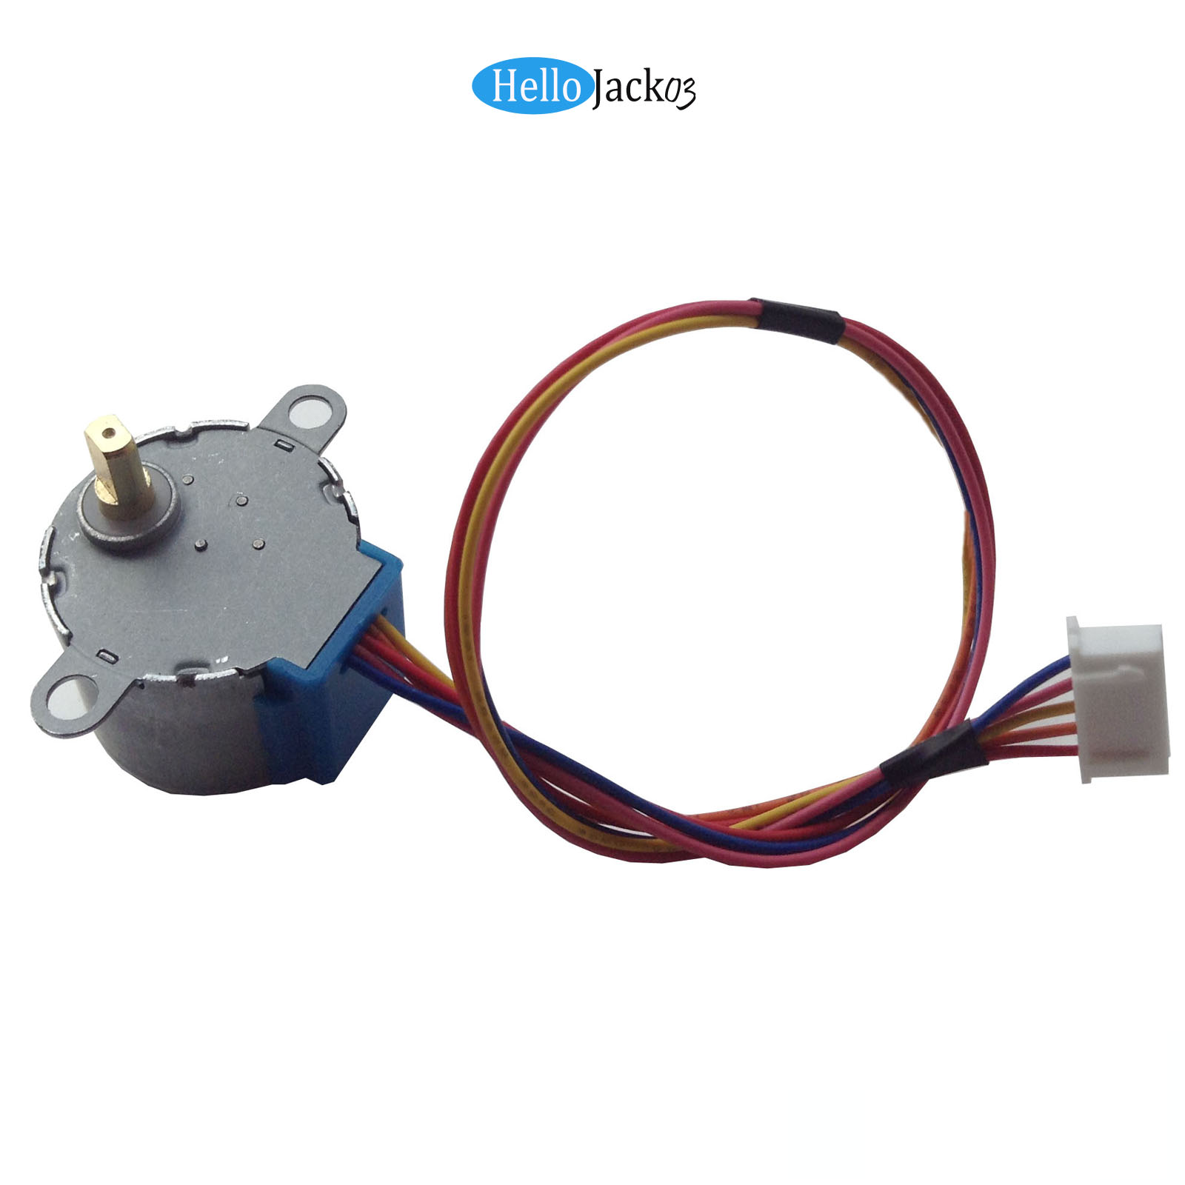
You must confirm if the stepping motor is a four phase or two phase

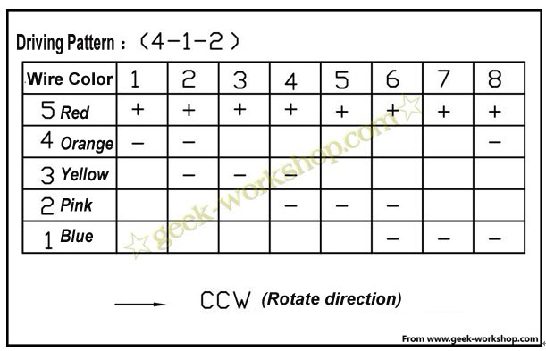
- Wiring
- Features:
Speed down stepper motor
Diameter：28mm
voltage：5V
step Angle：5.625 x 1/64
reduction ratio：1/64
5 line 4 phases model can use common uln2003 chip driver, also can be connect into 2 phase

The stepper motor no-load power consumption under 50 mA, with 64 times speed reducer, the output torque is larger, can drive heavy load, very suitable for development board.

Note: this is slower than those item without speed reducer, you can stick a piece of paper on the output shaft for observation.

Stepper Motor Driver(UL2003)
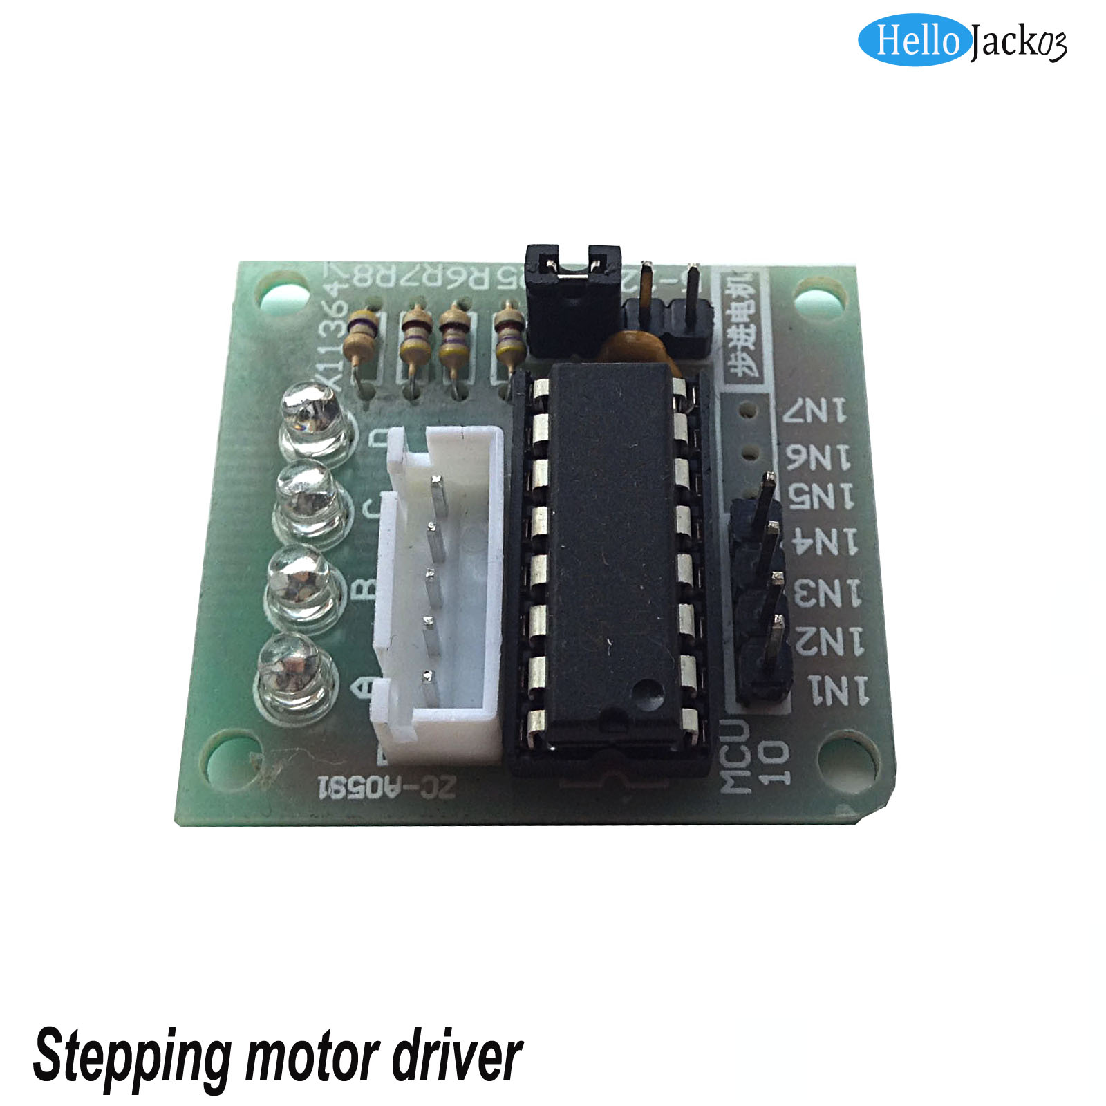
- Hardware connection diagram
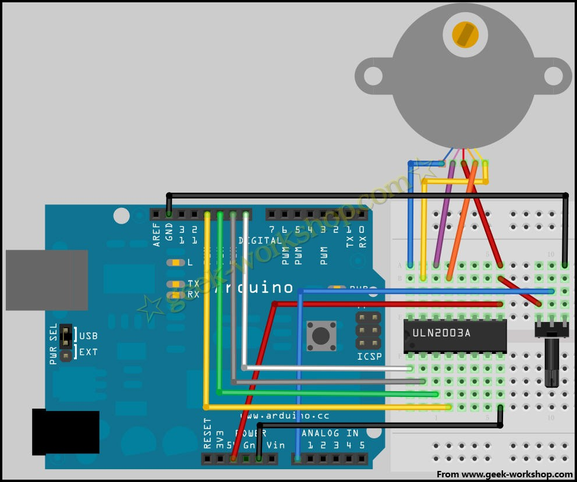

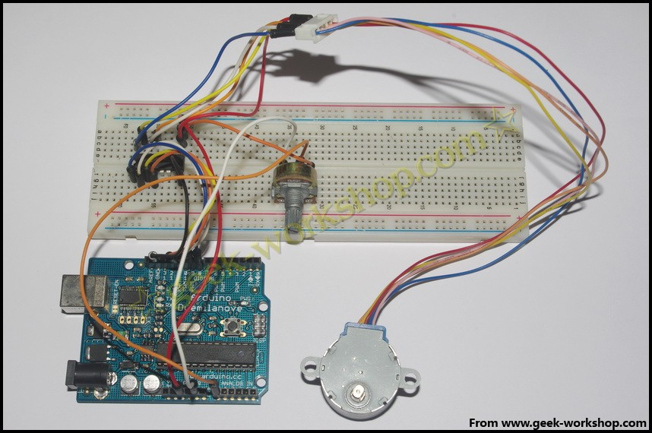
Download the code to Arduino to see what happen

